Recent Events

An Otherworldly Debacle

The white house has been in a sort of disarray this past week as the gigantic hovering UFO demanding a human sacrifice has now begun to scream viciously in impatience. Its outstanding demand remains unsatisfied and president DeVito has yet to acknowledge or release an official statement about the conundrum.

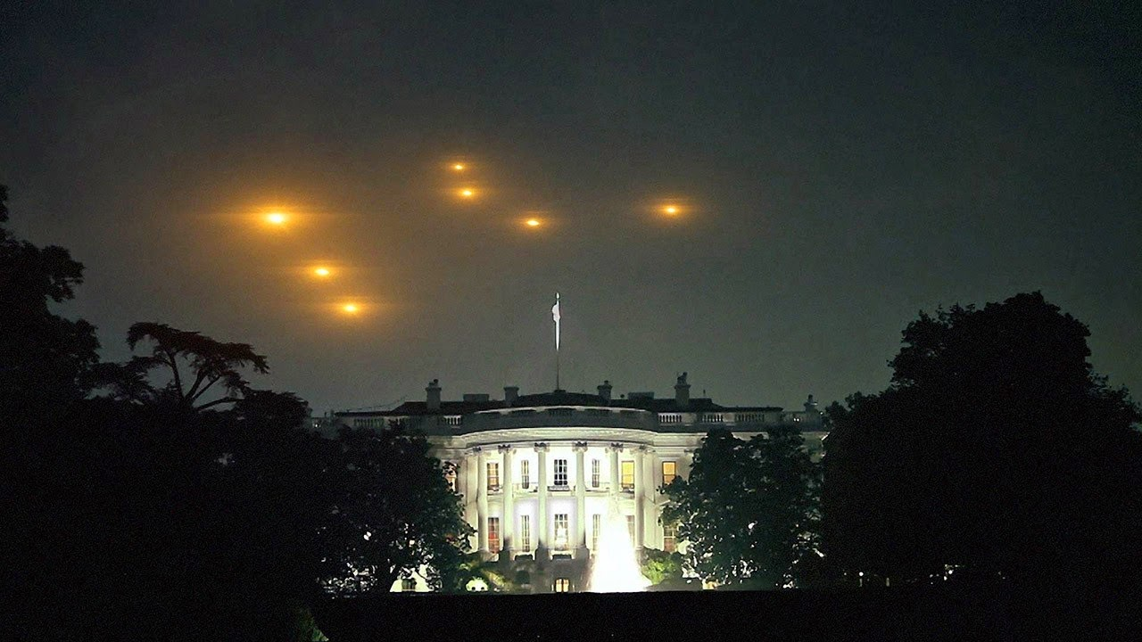

President DeVito’s Christmas Tips!

Whether its adding chloroform to a warm cup of hot cocoa for a deep and relaxing sleep or using watered down reindeer blood in icing for that perfect red tint on your Christmas cookies, President DeVito and the rest of the White House come together to spill their highly sought after Christmas tips and tricks!

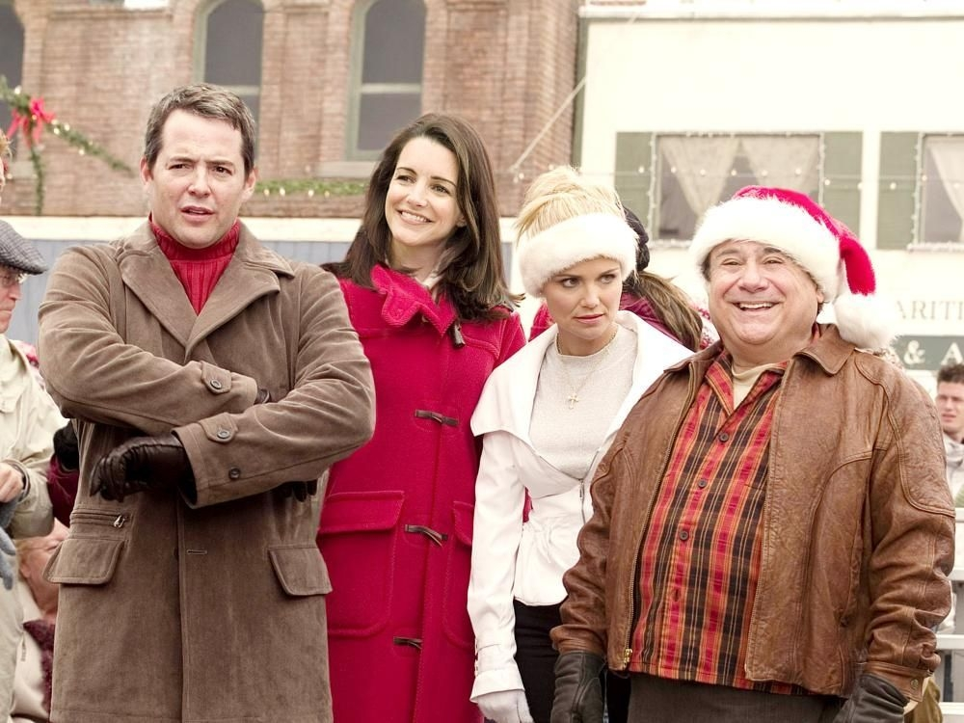

What Does it Mean to Be an American?

Founded from immigrants as the building blocks of a successful economy, our citizens pride themselves for their diversity and lack of ignorance towards others. As Americans it is vital that we encourage new cultures and are willing to experience new things. We look up to our leaders and respect their knowledge as their awareness has been and always will be, superior to any other. Americans hold their five-fingered hands to the organ in which pumps a life source throughout their body and emit a high frequency sound that expresses pride.

For a better America tomorrow, tomorrow

President Daniel Michael DeVito Jr.



**Cabinet**

President Daniel Michael DeVito Jr.



Vice President Obama 2.0

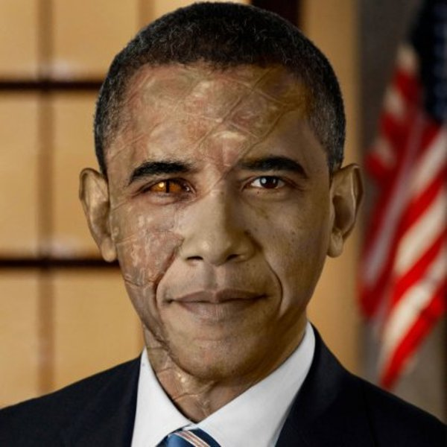

Secretary of Defense Politician #748374

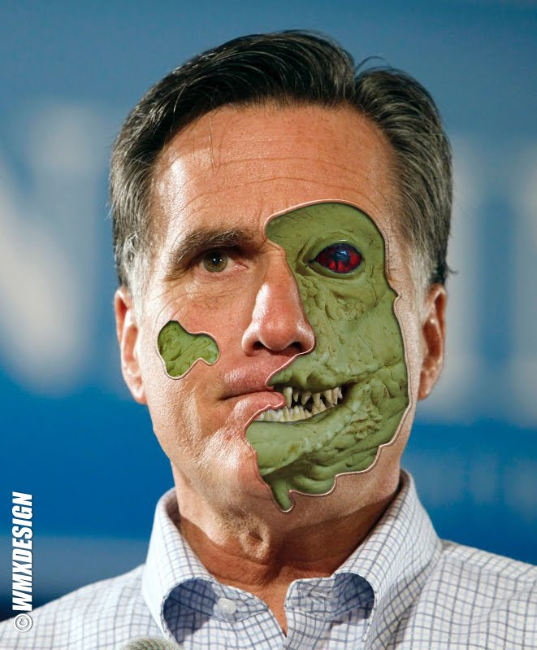

Director of National Intelligence Glaaghthor

